Captured the pre change network set up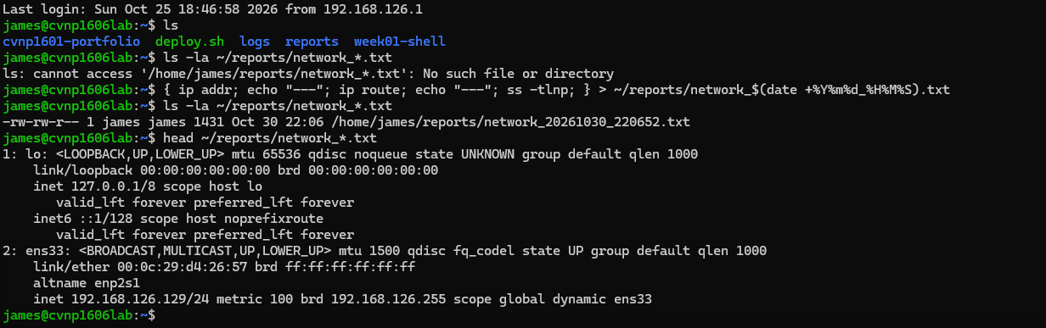
Did the show commands and tested both pings with success 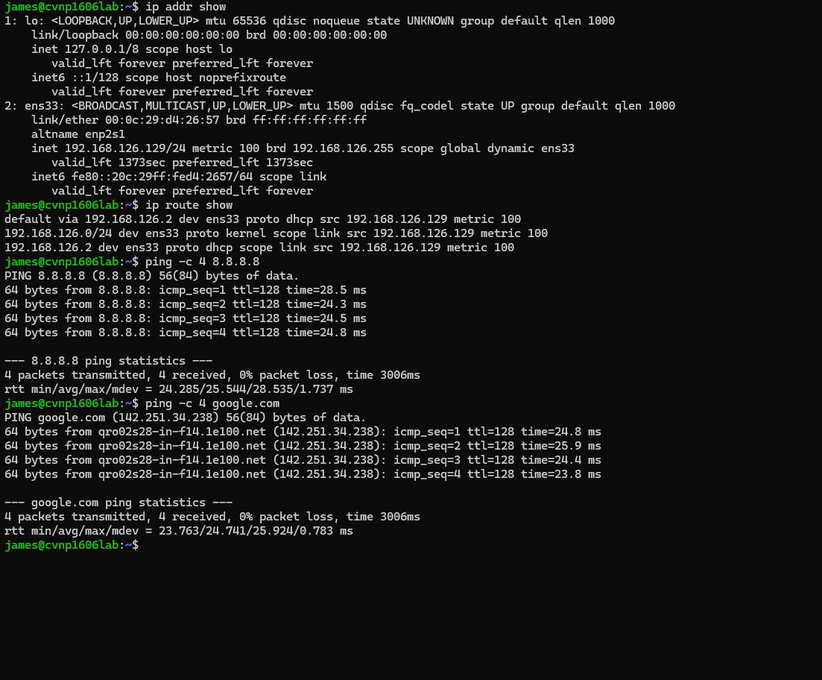
The network interface is up and has assigned a ip address the default route exists through gate way 192.168.126.2 both ping attempts were successful no network issues were found.
Tasks three wasnt needed with successful pings right away

Ran through the commands to list that it was listening on port 22 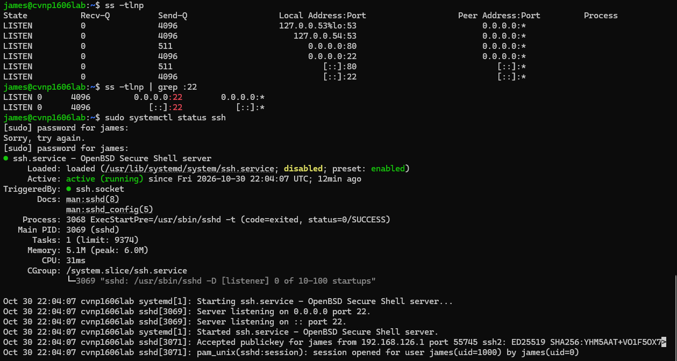
When running the ssh command I was running into a issue were it was asking for a password but I don't recall setting one for what it was asking and even if i did it would be password1 thats my normal for these vms 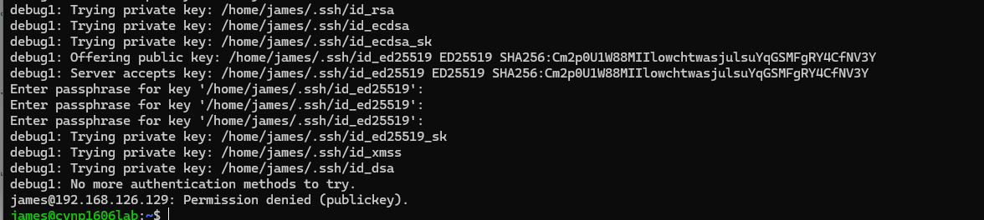
The difference between connection refused and timed out is refused means it connected but didnt have the required verification or auth to access it time out is it cant reach where its trying to contact period

Post fix capture

